Ex. No. 2 | Working with HTML5 Form and Media Elements
Date of Exercise | 24 July 2026
GitHub Host Link | https://gautham75.github.io/Web-Technology-Lab/

Aim
To design and develop a responsive webpage using HTML5 form controls, multimedia elements (<audio>, <video>), structural grouping elements (<fieldset>, <legend>), progress bars, and embedded frames (<iframe>).
Description
HTML Form Elements
All forms start with the <FORM> tag and end with </FORM>. All other form objects go between these two tags.
The form tag has two main properties: METHOD and ACTION.
<form action="/action_page.php" method="get"> </form>
The `<form>` element can contain one or more of the following form elements:
- <input>
- <textarea>
- <button>
- <select>
- <option>
- <fieldset>
- <label>

The `<input>` tag specifies an input field where the user can enter data. `<input>` elements are used within a `<form>` element to declare input controls that allow users to input data. An input field can vary in many ways, depending on the `type` attribute.
<form action="/action_page.php" method="get">
First name: <input type="text" name="fname"><br>
Last name: <input type="text" name="lname"><br>
<input type="submit" value="Submit">
</form>

Input Types:
Here are the different input types you can use in HTML
<input type="button">
<input type="checkbox">
<input type="date">
<input type="datetime-local">
<input type="email">
<input type="file">
<input type="hidden">
<input type="image">
<input type="month">
<input type="number">
<input type="password">
<input type="radio">
<input type="range">
<input type="reset">
<input type="search">
<input type="submit">
<input type="tel">
<input type="text">
<input type="time">
<input type="url">
<input type="week">

Textarea Element
The `<textarea>` tag defines a multi-line text input control. A text area can hold an unlimited number of characters, and the text renders in a fixed-width font (usually Courier). The size of a text area can be specified by the `cols` and `rows` attributes, or even better; through CSS' `height` and `width` properties.
<textarea rows="4" cols="50">
</textarea>
Select Element
The `<select>` element is used to create a drop-down list. The `<option>` tags inside the `<select>` element define the available options in the list.
<select>
<option value="volvo">Volvo</option>
<option value="saab">Saab</option>
<option value="mercedes">Mercedes</option>
<option value="audi">Audi</option>
</select>
Fieldset Element
The `<fieldset>` tag is used to group related elements in a form. The `<fieldset>` tag draws a box around the related elements.
<form>
<fieldset>
<legend>Personalia:</legend>
Name: <input type="text"><br>
Email: <input type="text"><br>
Date of birth: <input type="text">
</fieldset>
</form>
Media Elements:
The following are the most popular media elements.
- audio:
Audio element is used for defining or creating a music element in your simple HTML page.
<audio controls>
<source src="1.mp3" type="audio/mpeg">
</audio>
- video:
The Video element creates a video element in your HTML page.
<video controls>
<source src="1.mp4" type="video/mp4">
</video>
- embed:
It is also called a container because as the name suggests it is used for defining containers for the external applications or we can say plug-ins for the applications.
<embed src="1.swf">

Program:
<!DOCTYPE html>
<html lang="en">
<head>
<meta charset="UTF-8">
<meta name="viewport" content="width=device-width, initial-scale=1.0">
<title>Ex.No:02 - Working with HTML5 Form and Media Elements</title>
<style>
/* CSS for Ex.No:02 Lab Exercise */
body {
font-family: Arial, Helvetica, sans-serif;
background-color: #f0f2f5;
margin: 0;
padding: 20px;
color: #333333;
}

.container {
max-width: 960px;
margin: 0 auto;
background-color: #ffffff;
border: 1px solid #cccccc;
padding: 20px;
box-shadow: 0 4px 10px rgba(0,0,0,0.1);
}

/* Header Styling */
header {
display: flex;
align-items: center;
justify-content: space-between;
padding-bottom: 15px;
border-bottom: 1px solid #e0e0e0;
}

.profile-section {
display: flex;
align-items: center;
gap: 20px;
}

.profile-img {
width: 100px;
height: 100px;
border-radius: 50%;
object-fit: cover;
border: 2px solid #0056b3;
}

.profile-name {
font-size: 26px;
color: #222222;
margin: 0;
}

/* Navigation Bar */
nav {
background-color: #f8f9fa;
border: 1px solid #e0e0e0;
margin: 15px 0 20px 0;
padding: 8px 15px;
display: flex;
justify-content: space-between;
align-items: center;
}

.nav-links {
display: flex;
gap: 20px;
}

.nav-links a {
color: #0056b3;
text-decoration: none;
font-weight: bold;
font-size: 14px;
}

.nav-links a:hover {
text-decoration: underline;
}

.search-box input[type="search"] {
padding: 5px 10px;
border: 1px solid #ccc;
border-radius: 4px;
font-size: 13px;
}

/* Main Grid Layout */
.main-content {
display: flex;
gap: 20px;
margin-bottom: 20px;
}

/* Sidebar Skills Table */
.sidebar {
width: 220px;
flex-shrink: 0;
background-color: #fafafa;
border: 1px solid #e0e0e0;
padding: 12px;
}

.skills-table {
width: 100%;
border-collapse: collapse;
}

.skills-table td {
padding: 8px 4px;
font-size: 14px;
border-bottom: 1px solid #eeeeee;
}

.skills-table progress {
width: 100%;
height: 12px;
}

/* Content Area */
.content-area {
flex: 1;
}

/* Media Container */
.media-container {
background-color: #000000;
border-radius: 6px;
overflow: hidden;
margin-bottom: 20px;
text-align: center;
}

.media-container video {
width: 100%;
max-height: 280px;
display: block;
}

.audio-player {
margin-top: 10px;
padding: 10px;
background-color: #f1f3f4;
border-radius: 4px;
}

/* Forms Section */
.forms-grid {
display: flex;
gap: 15px;
margin-bottom: 20px;
}

fieldset {
flex: 1;
border: 1px solid #cccccc;
border-radius: 6px;
padding: 15px;
background-color: #ffffff;
}

legend {
font-weight: bold;
color: #333333;
padding: 0 8px;
}

.form-group {
margin-bottom: 10px;
display: flex;
align-items: center;
}

.form-group label {
width: 130px;
font-size: 13px;
color: #444444;
}

.form-group input[type="text"],
.form-group input[type="password"],
.form-group input[type="date"],
.form-group input[type="tel"],
.form-group input[type="email"],
.form-group input[type="url"],
.form-group select,
.form-group textarea {
flex: 1;
padding: 5px 8px;
border: 1px solid #ccc;
border-radius: 4px;
font-size: 13px;
}

.form-group textarea {
resize: vertical;
}

.radio-group, .checkbox-group {
display: flex;
align-items: center;
gap: 10px;
font-size: 13px;
}

.submit-btn {
background-color: #f0f0f0;
border: 1px solid #adadad;
padding: 6px 16px;
border-radius: 4px;
cursor: pointer;
font-weight: bold;
margin-top: 10px;
}

.submit-btn:hover {
background-color: #e0e0e0;
}

/* Embed & Iframe Section */
.embed-grid {
display: flex;
gap: 15px;
margin-bottom: 20px;
}

.embed-box {
flex: 1;
border: 1px solid #cccccc;
border-radius: 4px;
overflow: hidden;
}

.embed-box iframe, .embed-box embed {
width: 100%;
height: 220px;
border: none;
}

/* Footer Styling */
footer {
border-top: 1px solid #e0e0e0;
padding-top: 15px;
font-size: 13px;
color: #666666;
}

footer p {
margin: 4px 0;
}
</style>
</head>
<body>

<!-- HTML Comment: Ex.No:02 WORKING WITH HTML5 FORM AND MEDIA ELEMENTS -->
<!-- Objective: Build a website conforming to HTML5 standards with doctype, html, head, title, body, div, p, headings, image, anchor, table, audio, video, embed, iframe, form, input, select, progress, fieldset, label, etc. -->

<div class="container">

<!-- Header Section -->
<header>
<div class="profile-section">
<!-- Profile Image -->
<img
src="images/night_light.jpg"
alt="Night light image"
class="profile-img"
>
</div>
<div>
<h1 class="profile-name">Mr.Gautham Manoj</h1>
</div>
</header>

<!-- Navigation Bar -->
<nav>
<div class="nav-links">
<a href="#academics">Academics</a>
<a href="#achievements">Achievements</a>
<a href="#friends">Friends</a>
</div>
<div class="search-box">
<input type="search" placeholder="Search...">
</div>
</nav>

<!-- Main Section (Sidebar + Media Content) -->
<div class="main-content">

<!-- Sidebar Table with Skills and Progress Bar -->
<aside class="sidebar">
<h3>Skills</h3>
<table class="skills-table">
<tr>
<td>Photoshop</td>
</tr>
<tr>
<td><progress value="85" max="100"></progress></td>
</tr>
<tr>
<td>Java</td>
</tr>
<tr>
<td><progress value="75" max="100"></progress></td>
</tr>
<tr>
<td>C++</td>
</tr>
<tr>
<td><progress value="80" max="100"></progress></td>
</tr>
<tr>
<td>PHP</td>
</tr>
<tr>
<td><progress value="70" max="100"></progress></td>
</tr>
<tr>
<td>Javascript</td>
</tr>
<tr>
<td><progress value="90" max="100"></progress></td>
</tr>
</table>
</aside>

<!-- Center Media Section -->
<main class="content-area">

<!-- Video Element -->
<div class="media-container">
<video controls poster="data:image/svg+xml;utf8,<svg xmlns='http://www.w3.org/2000/svg' viewBox='0 0 500 280' width='500' height='280'><rect width='500' height='280' fill='%2365a30d'/><circle cx='250' cy='120' r='35' fill='%23ffffff'/><ellipse cx='220' cy='85' rx='10' ry='15' fill='%23ffffff'/><ellipse cx='280' cy='85' rx='10' ry='15' fill='%23ffffff'/><ellipse cx='195' cy='110' rx='8' ry='12' fill='%23ffffff'/><ellipse cx='305' cy='110' rx='8' ry='12' fill='%23ffffff'/><text x='250' y='210' font-family='sans-serif' font-weight='bold' font-size='20' fill='%23ffffff' text-anchor='middle'>HTML5 Video Element</text></svg>">
<source src="https://www.w3schools.com/html/mov_bbb.mp4" type="video/mp4">
Your browser does not support the video tag.
</video>
</div>

<!-- Audio Element -->
<div class="audio-player">
<p style="margin: 0 0 5px 0; font-size: 13px; font-weight: bold;">Audio Element Sample:</p>
<audio controls style="width: 100%;">
<source src="https://www.w3schools.com/html/horse.mp3" type="audio/mpeg">
Your browser does not support the audio element.
</audio>
</div>

</main>
</div>

<!-- HTML5 Form Section with Fieldsets -->
<form action="/action_page.php" method="get">
<div class="forms-grid">

<!-- Fieldset 1: Personal Information -->
<fieldset>
<legend>Personal Information</legend>

<div class="form-group">
<label for="fname">User name:</label>
<input type="text" id="fname" name="fname" placeholder="Enter the user name">
</div>

<div class="form-group">
<label for="pwd">Password:</label>
<input type="password" id="pwd" name="pwd" placeholder="Maxlength-10" maxlength="10">
</div>

<div class="form-group">
<label for="regno">Reg No:</label>
<input type="text" id="regno" name="regno" placeholder="UR15CS001">
</div>

<div class="form-group">
<label for="age">Age:</label>
<select id="age" name="age">
<option value="19-24">19-24</option>
<option value="25-30">25-30</option>
<option value="31-40">31-40</option>
</select>
</div>

<div class="form-group">
<label>Gender:</label>
<div class="radio-group">
<input type="radio" id="male" name="gender" value="Male">
<label for="male" style="width: auto;">Male</label>
<input type="radio" id="female" name="gender" value="Female">
<label for="female" style="width: auto;">Female</label>
</div>
</div>

<div class="form-group">
<label for="dob">DOB:</label>
<input type="date" id="dob" name="dob">
</div>

<div class="form-group">
<label for="favcolor">Favorite Color:</label>
<input type="color" id="favcolor" name="favcolor" value="#0056b3">
</div>

<div class="form-group">
<label for="photo">Change Profile Photo:</label>
<input type="file" id="photo" name="photo">
</div>

</fieldset>

<!-- Fieldset 2: Contact Information -->
<fieldset>
<legend>Contact Information</legend>

<div class="form-group">
<label for="address">Address:</label>
<textarea id="address" name="address" rows="3" placeholder="Enter your full address"></textarea>
</div>

<div class="form-group">
<label for="state">State:</label>
<select id="state" name="state">
<option value="">Select State</option>
<option value="Tamil Nadu">Tamil Nadu</option>
<option value="Kerala">Kerala</option>
<option value="Karnataka">Karnataka</option>
<option value="Maharashtra">Maharashtra</option>
</select>
</div>

<div class="form-group">
<label for="zipcode">Zipcode:</label>
<input type="text" id="zipcode" name="zipcode" placeholder="only 6 numbers" pattern="[0-9]{6}">
</div>

<div class="form-group">
<label for="mobile">Mobile:</label>
<input type="tel" id="mobile" name="mobile" placeholder="+9199999-99999">
</div>

<div class="form-group">
<label for="email">Email:</label>
<input type="email" id="email" name="email" placeholder="valid email">
</div>

<div class="form-group">
<label for="url">URL:</label>
<input type="url" id="url" name="url" placeholder="valid url">
</div>

<div class="form-group">
<div class="checkbox-group">
<input type="checkbox" id="verify" name="verify">
<label for="verify" style="width: auto;">I verified</label>
</div>
</div>

<div>
<input type="submit" value="Submit" class="submit-btn">
</div>

</fieldset>

</div>
</form>

<!-- Embed & Iframe Media Elements -->
<div class="embed-grid">

<!-- Embedded Document / Iframe -->
<div class="embed-box">
<iframe title="Document Preview" srcdoc="<body style='font-family:sans-serif;padding:15px;'><h3>Ex.No:2 Working with HTML5 Form and Media Elements</h3><p>Build a website that conforms to HTML5 standards and has form, media elements, fieldsets, and controls.</p></body>"></iframe>
</div>

<!-- Embedded Google Maps Iframe -->
<div class="embed-box">
<iframe
title="Google Map Location"
src="https://maps.google.com/maps?q=Karunya%20University,%20Coimbatore&t=&z=13&ie=UTF8&iwloc=&output=embed"
allowfullscreen
></iframe>
</div>

</div>

<!-- Footer Section -->
<footer>
<p>Your address</p>
<p>&copy; 2020-2021. (Register number) - Web Technology Lab Batch 1. All Rights Reserved.</p>
</footer>

</div>

</body>
</html>

Output:
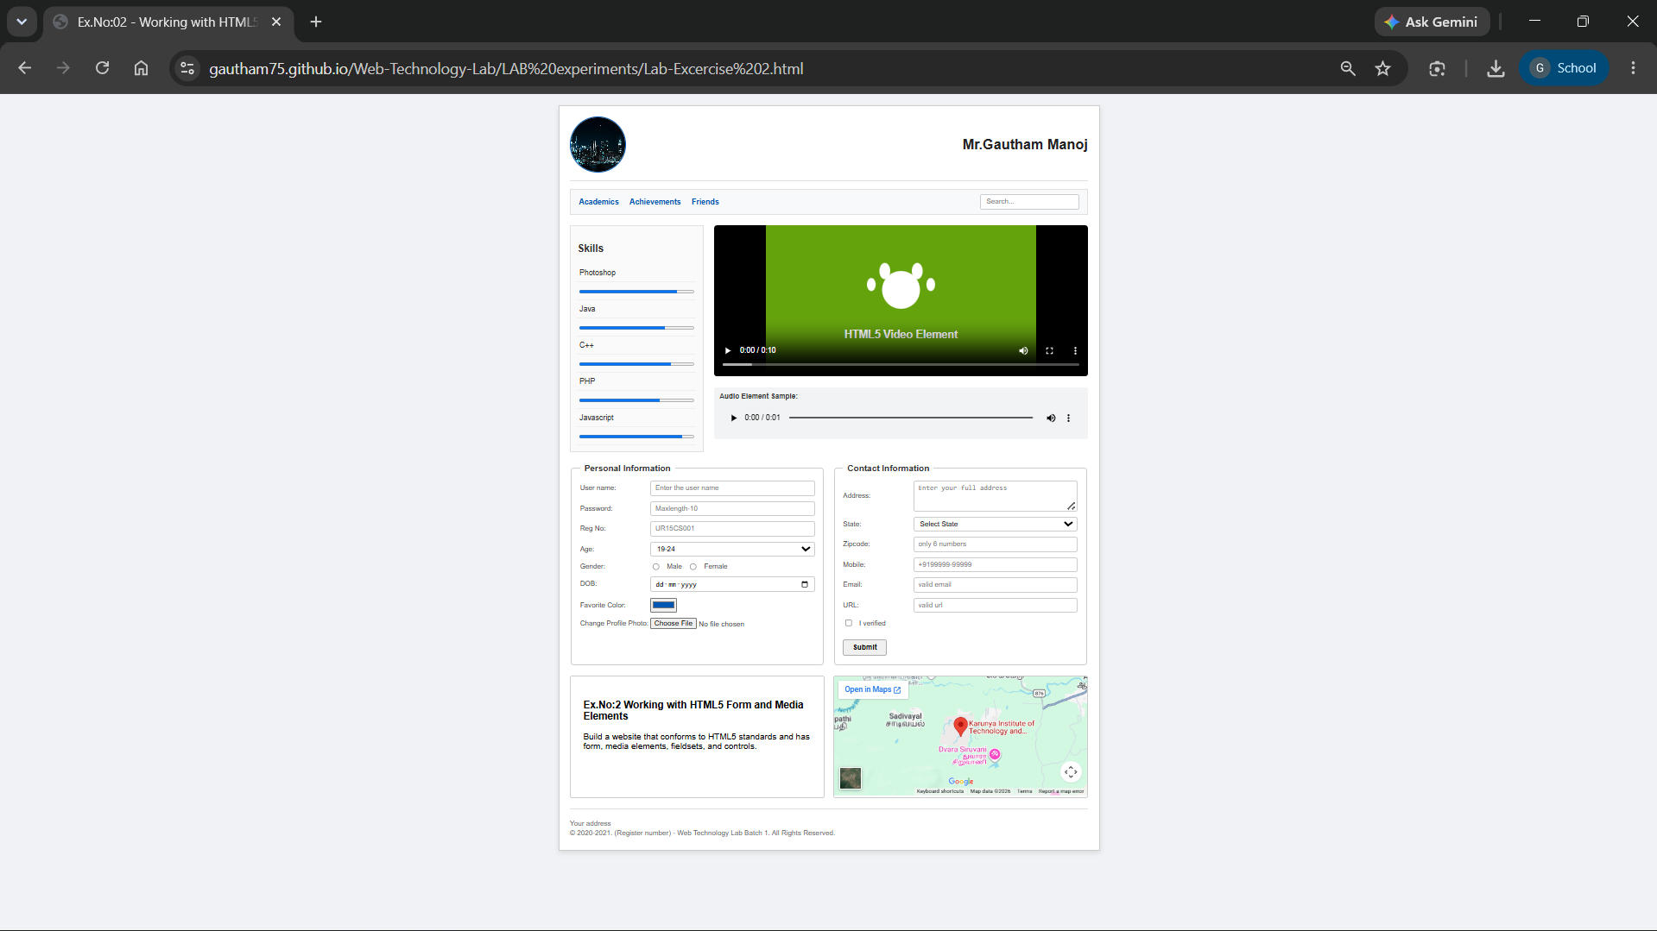

Result:
The HTML5 webpage featuring form controls, media elements (<audio>, <video>), embedded frames (<iframe>), and skill progress bars was successfully designed, implemented, and verified according to the lab layout requirements.

